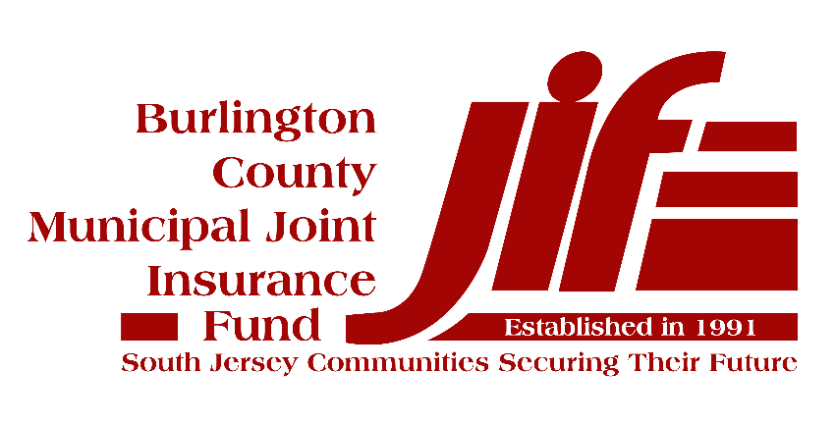

  - Information Technology Security Practices Policy
  - For Tier 2 Compliance with the MEL Cyber Risk Management Plan

Document Management
Document Owner: | Member Municipality
Document Name: | Information Security/Technology Practices Policy for Tier 2 Compliance
Version No: | Version: 1.0
Adoption Date:
Distribution Date:
Author (Source):
Last Review Date: | 07/1/19
Next Review Date: | 07/1/20
Data Classification: | Sensitive

Table of Contents
Document Management 2
1. Policy Statement 4
2. Reason for the Policy 4
3. Scope 4
4. Tier 2 Technical Policies 4
4.1 Server Physical Security Policy 4
4.2 Access Control Policy 5
4.3 Acceptable Use Policy 5
4.4 “Protected Data” Policy 6
4.5 Password Policy 6
4.6 Technology Support 7
4.7 Leadership Has Expertise 7
4.8 Governing Body Adopts Information Technology Standards Policy for Tier 2 Compliance 7

Policy Statement
The Information Security/Technology Practices Policy defines the information security practices necessary to ensure the security of our information systems and the information that they store, process, and/or transmit.

Reason for the Policy
Our municipality acts as the custodian of a wealth of sensitive information relating to the services we provide and the constituents we serve. Accordingly, an appropriate set of security measures must be implemented to guard against unauthorized access to, alteration, disclosure, or destruction of this information and/or the information systems that store, process, or transmit it.
This policy affirms our commitment to information security by specifying the policies and standards necessary to achieve our security objectives, including compliance with all Federal and State requirements and Tier 2 of the Municipal Excess Liability Fund’s Minimum Technology Proficiency Standards.

Scope
All information systems, including those operated by a third party, are expected to comply with this policy. In addition, all personnel, contractors, and vendors are expected to comply with this policy.

Our municipality has access to the expertise necessary to support critical technology decision making, including the following examples:
- XXX, IT Director
- YYY, Outside Vendor
- ZZZ, Consultant

Non-compliance with this policy can result in disciplinary actions in accordance with your municipality’s disciplinary policy.

Tier 2 Technical Policies

Server Physical Security Policy
Ensuring that access to servers is restricted to a “need to access” basis reduces the likelihood that those systems or the data they contain will be compromised. The objective of the Server Physical Security Policy is to ensure that sufficient controls are in place to prevent unauthorized access to our servers.
Our Approach:
- Our servers are housed in a locked server rack or room to prevent unauthorized access.
- Gaining access to our servers requires a physical key, access badge and/or combination door lock.
- Access to the server room is approved by the highest ranking administrative official in the municipality and/or the IT Director, and is restricted to a “need to access” basis.
- Each quarter the server access list is reviewed by the highest ranking administrative official in the municipality and/or the IT Director to ensure that only those with a current need to access, have access.
- When access card or key is secured from the individual, the list is updated and the means of access is disabled or collected.

Access Control Policy
Ensuring that the level of system and information access is appropriately restricted is critical to ensuring information security. The objective of the Access Control Policy is to provide guidance on restricting access to a “need to access” basis.
Our Approach:
- Administrator rights on desktops are only granted when approved by the highest ranking administrative official in the municipality and/or the IT Director.
- Access to key applications and network resources, including file shares, is access controlled.
- Employee access is granted when a new person is hired, and the hiring manager consults with the highest ranking administrative official in the municipality and/or the IT Director to determine the level of access and equipment that the new employee needs to perform their job function (e.g., key cards, Office 365, network, key applications, etc.)
- Employee access is removed when an employee is terminated/leaves the municipality. The employee’s manager submits written notification to the highest ranking administrative official in the municipality and/or the IT Director. Where possible, the request should proceed the person’s termination/leave by 48 hours to ensure that IT has the time to disable access.
- Conduct employee access rights reviews for key systems on a periodic basis per the following schedule:
  - Active Directory/Quarterly/Director of IT
  - Server Room/ Quarterly /Director of IT
  - 3rd Party Contractors (e.g. Edmunds)/Quarterly/CFO
- The number of “administrators” for key systems including any 3rd Party Contractors (e.g. Edmunds) are kept to the minimum number required to ensure effective and secure operation. The number of personnel with administrative level access to these systems is reviewed quarterly by the highest ranking administrative official in the municipality and/or the IT Director. Records for this review are kept in the Cloud.

Acceptable Use Policy
All employees need to receive appropriate guidance to the acceptable use of our computing assets including appropriate use of the Internet and email. The objective of the Acceptable Use Policy is to ensure that all employees have the information security knowledge necessary to minimize risk to themselves and our municipality when using computing assets.
Our Approach:
- We publish an Acceptable Use Policy. (See page 24 of the MEL Model Personnel Policies and Procedures Manual.)
- Employees formally acknowledge their receipt and understanding of the Acceptable Use Policy when hired and annually thereafter.

“Protected Data” Policy
The security applied to “Protected Data” when stored in files and/or transmitted needs to be adequate to meet any legal, regulatory, or contractual obligations relating to the data. The objective of the “Protected Data” Protection Policy is to outline user responsibilities when working with “Protected Data.”
Our Approach:
- “Protected Data” is defined as:
  - Personally Identifiable Information (PII) including: Social Security numbers, checking account numbers, birthdate, driver’s license number, passport number, and xxx.
  - Protected Health Information (PHI) including: health insurance numbers, medical diagnostic codes, medical records, and xxx.
  - Payment Card Industry (PCI) information including: credit card numbers (includes payer account number and sensitive authentication data). See PCI DSS (Payment Card Industry Data Security Standard) regulation for additional guidance.
- All files stored or transmitted that contain protected data are required to be encrypted (AES - Advanced Encryption Standard-256 or stronger, which is the norm used worldwide to encrypt data) using a password that conforms with our Password Policy. Acceptable file protection includes the following examples:
  - Microsoft Word password protection
  - Microsoft Excel password protection
  - Adobe Acrobat password protection
  - WinZip password protection
- Passwords used for encrypted files should be stored in a safe and secured location.

Password Policy
All information and computing assets should be protected by passwords whose “strength” is proportional to the value of the asset. The objective of the Password Policy is to ensure that users construct passwords that minimize the likelihood that the assets they protect will be accessed by unauthorized individuals.
Our Approach:
- Employees are required to use strong, unique passwords comprised of at least 8 characters and include upper and lower‐case letters, symbols, and numbers.
  - Longer passwords (10 or more characters) are preferable and encouraged.
  - Administrator passwords should be 12 characters or more in length.
  - Passwords are changed at least annually and/or when known to be compromised.

Technology Support
Municipal staff or IT contractors are available to support all municipal employee’s technology usage and respond to security incidents.
Our Approach:
- Distribute IT contact information to municipal employees annually and update contact lists when a change occurs.

Leadership Has Expertise
Organization leadership has access to expertise that supports technology decision making (i.e., risk assessment, planning, and budgeting). This can be any combination of officials, employees, contractors/consultants, or citizen volunteers as appropriate to the municipality.
Our Approach:
- Meet with IT Professionals at least annually to discuss the contents of this document to ensure that your Municipality can adhere to the standards outlined in this policy.

Governing Body Adopts Resolution for Technology Risk Management Standards in Compliance with the NJ MEL Cyber Risk Management Plan’s Tier 2 Requirements
See separate Resolution “Sample Tier 2 Information Technology Standards Policy Resolution.docx.”

