Fixed Ladder Inspection Checklist
Suggested frequency once per year
 | Entity: |  |  | Inspection Date: / / 201
 | Name of Inspector: |  |  | Title:
 | Ladder ID #
 | # |  | Condition: Write line #’s and comments on back for all “Needs Repair” listings
 |  | Reference: 29 CFR 1910.27 (2017) & ANSI A 14.3 |  |  | Needs repair | O.K | Date repaired
1 |  | Loose rungs (considered loose if they can be moved at all by the hand)
2 |  | All rungs shall have a minimum diameter of 3/4 “for metal ladders?  If the ladder is embedded in concrete and serves as an access to pits or other atmospheres that cause corrosion and rusting, the rungs must be at least one inch in diameter or be painted or treated to resist corrosion and rusting.
3 |  | The distance between rungs, cleats, & steps shall not exceed 12“& shall be uniform throughout the length of the ladder.
4 |  | Are the rungs of ladders designed so that the foot cannot slip off the end?
5 |  | The minimum clear length of rungs or cleats shall be 16“.
6 |  | Side rails used as a climbing aid shall be of such cross sections as to afford adequate gripping surface without sharp edges, splinters, or burrs.
7 |  | A clear width of at least 15” shall be provided each way from the centerline of the ladder in the climbing space, except when cages or wells are necessary.
8 |  | Cages shall be provided on ladders of more than 24 feet to a maximum unbroken length of 30 feet. Can substitute ladder safety device
9 |  | The perpendicular distance from the centerline of the rungs to the nearest permanent object on the climbing side of the ladder 30“ for a pitch of 90 º
10 |  | The distance from the centerline rungs, cleats, or steps to the nearest permanent object in back of the ladder shall be not less than 7 inches.
11 |  | Step-across distance for the nearest edge of ladder to the nearest edge of equipment or structure shall not be more than 12“or less than 2 ½ “.
12 |  | The side rails of the through ladder extensions shall extend 3½ feet above the parapets & landings.
13 |  | The preferred pitch of fixed ladders shall be considered to come in the range of 75º & 90º with the horizontal.
Reference diagram on page two for proper nomenclature and dimensions
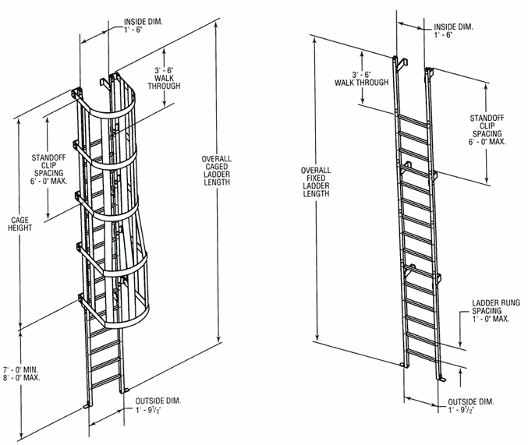

COMMENTS
___________________________________________________________________________________________________________________________________________________________________________________________________________________________________________________________________________________________________________________________________________________________________________________________________________________________________________________________________________________________________________________________________________________________________________________________________________________________________________________________________________________________________________________________________________________________________________

